‘DIGGING UP SQUARE ROOTS’
An illustrated presentation by David Glover
6pm on Saturday 14th October
at St Paul’s Church, King Cross HX1 3NU

Stories of four adjacent historic sites near The Piece Hall
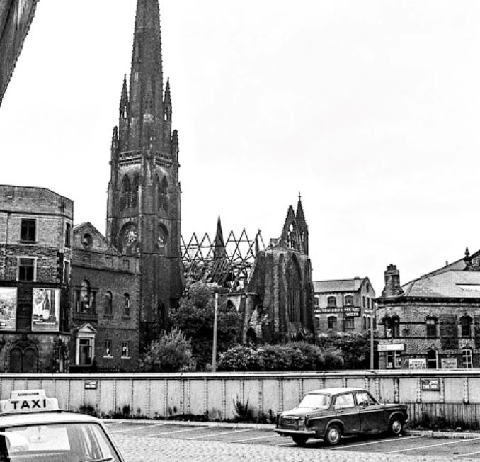
From the first building project of John Caygill (of Piece Hall fame)
David will speak about -
+ the Square Chapel Congregationalists of Titus Knight
+ the theft of Rev Enoch Mellor’s huge ham
+ the hot air balloon disaster of 1863
+ the remarkable factory of Blakey Emmott & Co
+ the destruction of Square Church by fire in 1972

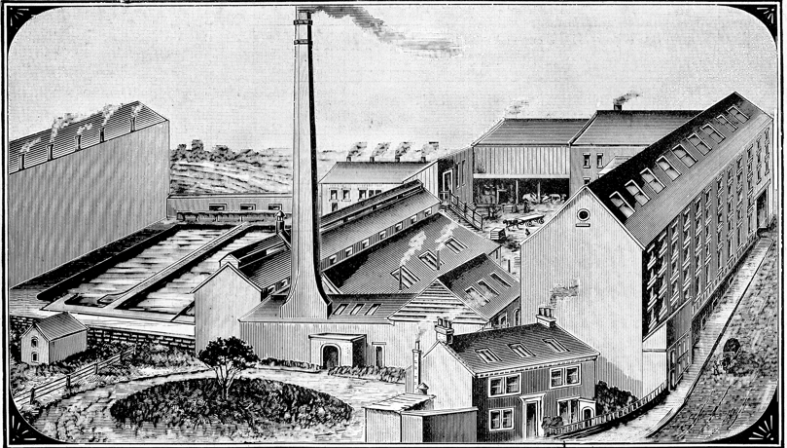

FREE ENTRY - REFRESHMENTS - DONATIONS WELCOME
IN AID OF THE HALIFAX & DISTRICT ORGANISTS’ ASSOCIATION

