Membership Form

Title Mr/Mrs/Miss/Ms/Dr/Prof

First name(s) ………………………………..…………………..

Surname ………………………………..…………………..

Address ………………………………..…………………..

………………………………..…………………..

………………………………..…………………..

Postcode ………………………………..…………………..

Telephone ………………………………..…………………..

Email ………………………………..…………………..

|  |  |
| --- | --- |
| Adult (£15.00) 🞏 | Retired/student(£12.00) 🞏 |

I enclose a cheque for £ ………… payable to “Halifax & District Organists Association”.

**Gift Aid Declaration**

If you are a UK tax payer, the Association can reclaim tax on your subscription. All you need to do is to sign and date the declaration below.

I want the Association to treat all subscription and donations that I make from the date of this declaration until I notify you otherwise as Gift Aid.

Signature: ………………………………..…………………..

Date: ………………………………..…………………..

Please send this form and your payment to:

HDOA Membership, Rock Mount, Sowerby New Road, Sowerby Bridge, HX6 1LQ.

Organists’ Review

Organists’ Review is the leading magazine not just for organists, but for all those who love the instrument and its music. When it started life as The Organists’ Quarterly Record, it was produced exclusively for members of the IAO but progressively, through the initiative and imagination of successive editors, it has become a journal with a worldwide readership.

It aims to provide a kaleidoscope of the organ world, with articles and pictures covering a wide range of subjects. In addition to regular features such as reviews of new music and CDs, each issue explores in depth a theme of current interest.

Members can take out a year’s subscription to the Organists’ Review (four issues) for a special price of £23.80 (£20.00 for full-time students).

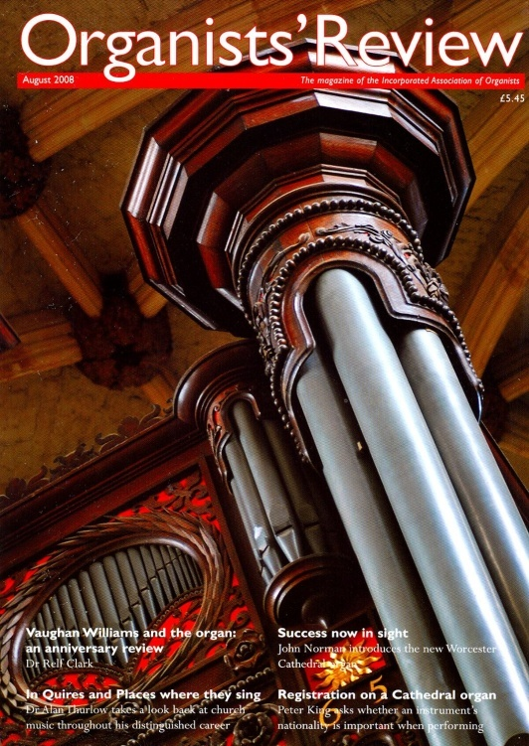

# C:\Documents and Settings\nick\My Documents\My Pictures\Halifax angel 2.JPG

## Halifax and District Organists’ Association

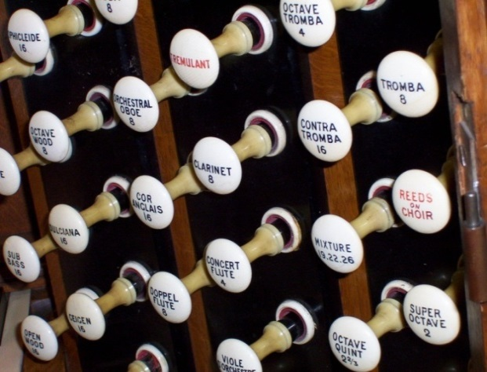

Interested in the organ and its music?

Then why not join the Halifax and District Organists’ Association?

You don’t need to play the organ (or any musical instrument at all) in order to become a member – just being interested in the instrument and its amazing repertoire is a good enough reason to join.

Simply fill in the membership form overleaf and send it to our Treasurer.

Who are we?

With members aged from their teens to their eighties, the Halifax Organists’ Association is one of a network of local associations covering much of the UK and affiliated to the nationwide Incorporated Association of Organists (IAO).

Both the Halifax Association and the IAO are registered charities.

What do we do?

We are here to promote and support organ music in the Calderdale area, to help with the improvement of standards at all levels from absolute beginner upwards, and to provide a forum where organists and organ lovers can meet and exchange ideas..

We have a programme of events through the winter months including talks, workshops, masterclasses, recitals and visits to organs in the area and further afield. And we also have purely social events such as an annual dinner.

All events are open to anyone interested, whether or not they are members - though we are delighted when people join!

In addition to these local events, there is the opportunity to attend the IAO Congress – a week-long series of visits to major instruments around the UK or overseas.

What does it cost?

Annual subscriptions are as follows:

Adult £15

Retired and students £12

Visit our Web Site

You can find out all the latest news about the Association at our web site: **http://www.hdoa.org.uk**.

The Organ

With a history dating back to Roman times, the organ is one of the most fascinating of musical instruments, and certainly the largest, the loudest and the most stunningly beautiful.

Organ works from the sixteenth century to the present day are still regularly performed on the instrument. Of all instruments, only the piano has a larger repertoire.

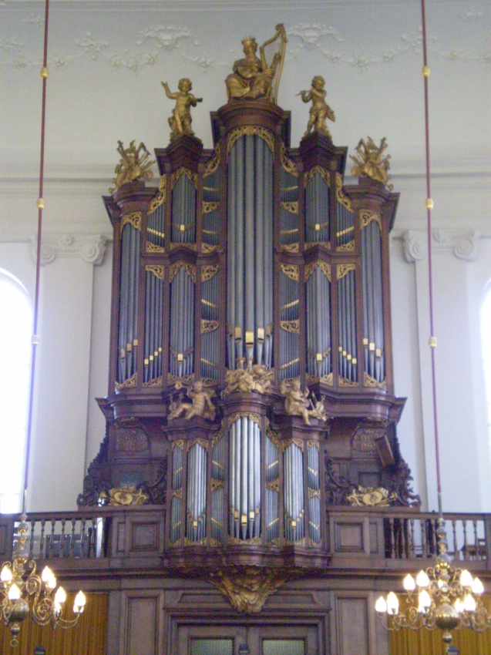

*Lutheran Church, den Haag*

Halifax & District Organists’ Association  
Charity registration number: 518606

Affiliated to the Incorporated Association of Organists.